Electronics Lesson 3

**Overview**

This lesson is to use what we learned from the past two lessons to create a traffic light.

Review

Instructor: Go over the programming concepts from the previous lesson.

To students: What is code?

Expected Answer: Code is a set of instructions.

To students: What are variables?

Expected Answer: Variables stores information.

To students: What are methods?

Expected Answer: Methods are a set of instructions grouped together.

To students: What does the *setup* method do?

Expected Answer: **The setup method run the instructions once.**

To students: What does the *loop* method do?

Expected Answer: **The loop method run the instructions in a continuous loop.**

To students: What does the *pinMode* method do?

Expected Answer: **The pinMode method sets a pin to send or receive electricity,**

To students: What does the *digitalWrite* method do?

Expected Answer: **The digitalWrite method controls the power of the electricity sent to the pin.**

To students: What does the *delay* method do?

Expected Answer: **The delay method waits for a certain amount of time.**

Big Concept #1: Traffic Light

To students: Can anyone tell me how a traffic light works?

Expected Answer: The green lights turns on for a few (5) seconds then the yellow light *blinks* for a few seconds then the red light turns on for a few (5) seconds. Note that when one light is on then the other lights are off.

Activity 1: Code and wire a traffic light.

Distribute the worksheets and setup the computers.

1. Have the students initialized three variables.

int GREEN = 8;

int YELLOW = 9;

int RED = 10;

1. Have the students work together to code and wire a traffic light.

Expected Answer:

Layout:

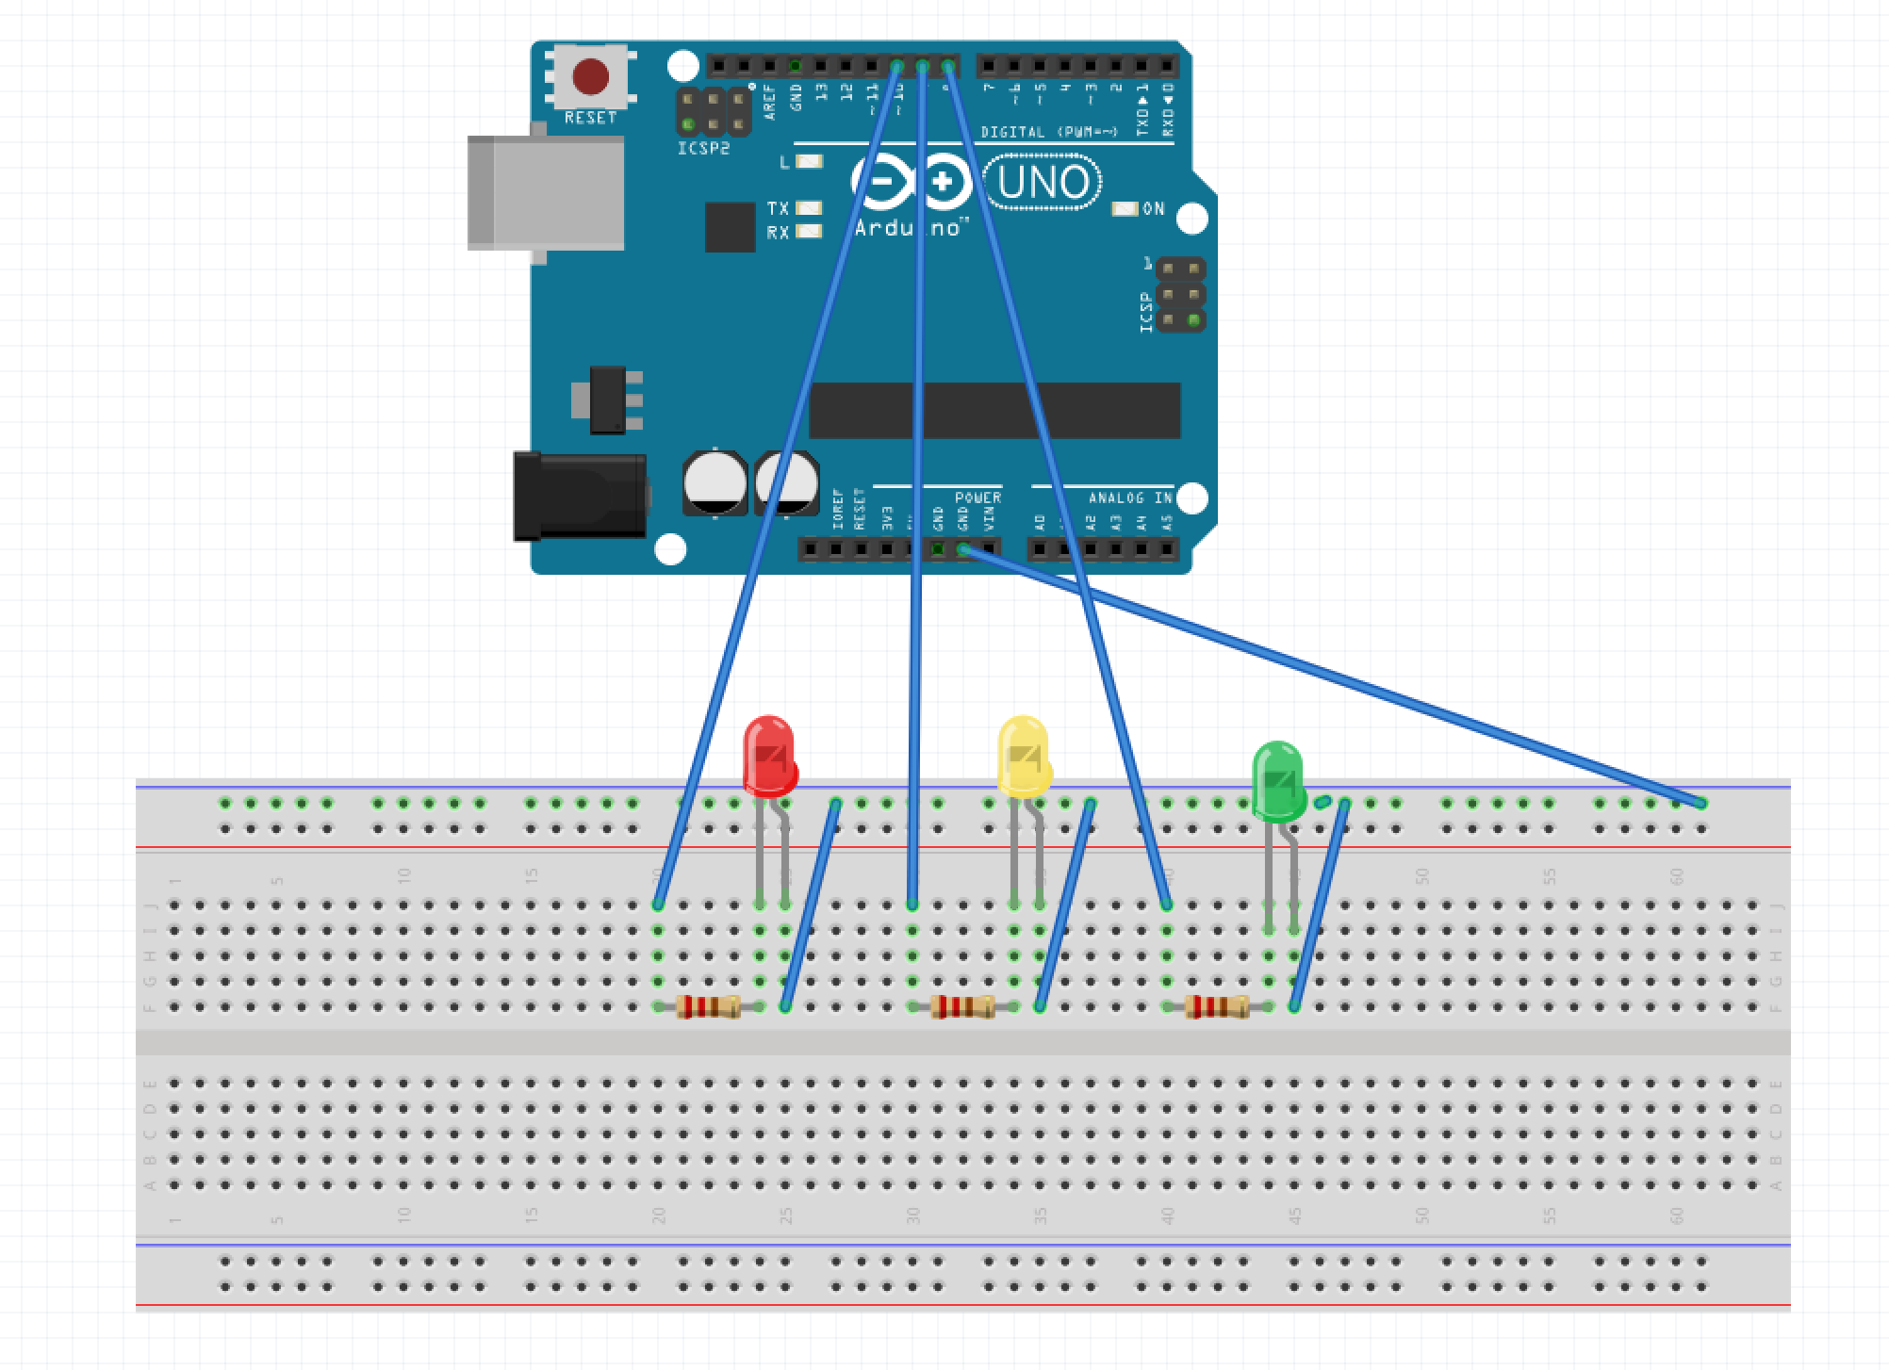

Code:

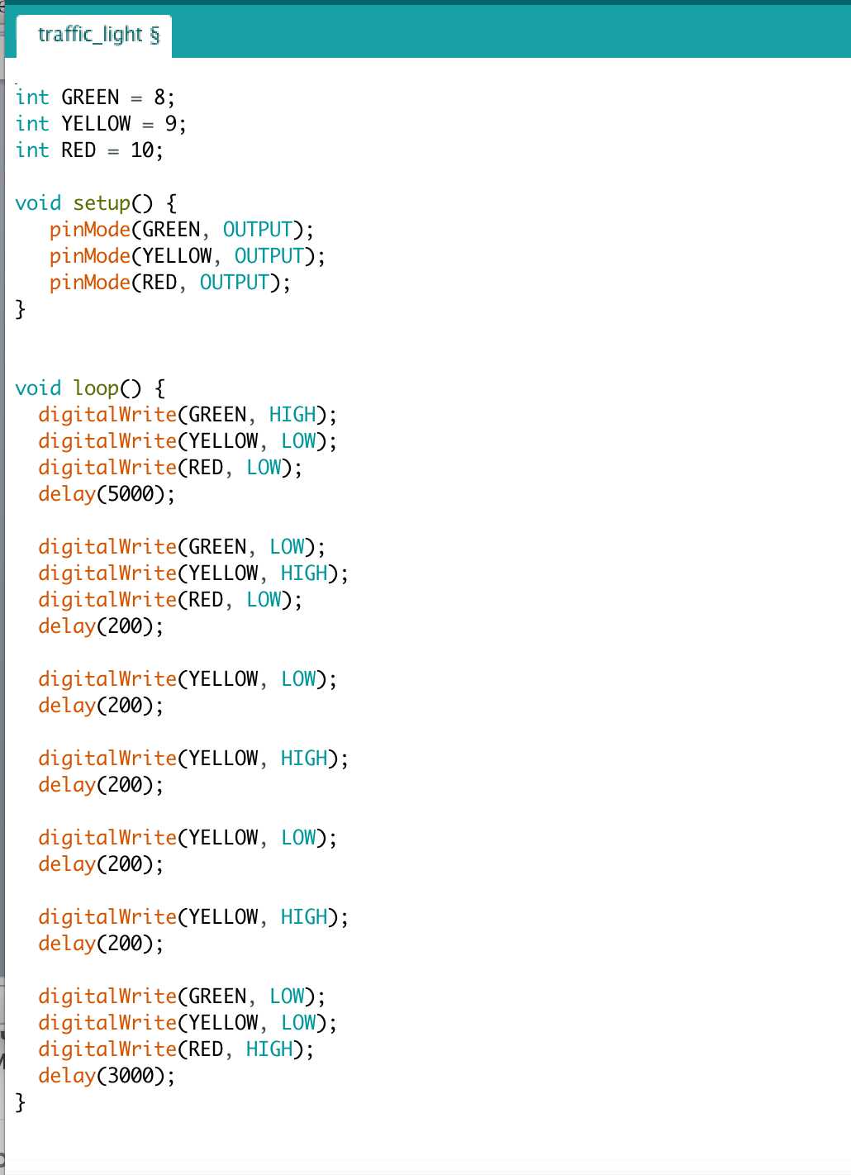

For those who are advanced, have them code a *for loop*. The simplest way to teach this is to show them the *for loop* code and have them figure it out how it works. See for more information: https://www.arduino.cc/reference/en/language/structure/control-structure/for/

Expected Answer:

